
School of Computing and Informatics
Data Structures and Algorithms
Final Assignment
Spring Semester, Year 2023
Student Name: Sara Mehrem
Student ID: 21110331
Section Number: 10

Contents
Min-Priority Queue 3
What is the Min-Priority Queue? 3
Min-priority Queue Applications 3
Abstract Data type of Min-Priority Queue 4
Time Complexity and Big-O Notation of Min-Priority Queue 4
Logical view\Design Specification of Min-Priority Queue 5
Selection Sort VS Merge Sort 6
Performance of Sorting Algorithm (Selection sort and merge sort) 6
Time Complexity 6
Big O notation 6
➔ Selection Sort: 7
➔ Merge Sort 7
Explain the Result 8
Space Complexity 8
Analyze the Operations of the Dijkstra’s Algorithm 9
Analyze the Operations of the Bellman-Ford Algorithm 10
Stack Data Structure 11
Pseudocode of Palindrome 11
Abstract Data Type 11
Stack, Formal Definition: 11
Stack Operations: 11
Logical view 11
The Call Stack 13
Spell Checker Application and Priority Queues 14
Spell Checker Application 14
Priority Queues 14
Evaluate and calculate Running Time/Big-O 15
Calculate the Running Time 15
Evaluation 15
Advantages of Encapsulation When Implementing any Data Structure as Abstract Data Type 15
➔ Data hiding / Abstraction 15
➔ Data Protection 16
➔ Flexibility 16
➔ Easy to Test 16
➔ Freedom to the Programmer in the Implementation Details 16
ADTs are a Basis for Object Oriented Programming 16
Implementation Independent Data Structures 16

Min-Priority Queue

What is the Min-Priority Queue?
Min-Priority Queue is a data structure (a way to store and organize data in memory), it is a list (collection of items), each item has a priority in addition to the data, the smallest one has a highest priority so it can be in the front on the queue. Min-Priority Queue allows efficient insertion, so it inserts items based on its priority and retrieval the element with the highest priority.

Min-priority Queue Applications
Dijkstra's Shortest Path Algorithm one of the applications of Min-Priority Queue, it is represented by finding the shortest path in the weighted graph, such as finding the shortest distance to reach the vertex of the curve or line efficiently, so the algorithm determines the shortest paths through Min-Priority Queue. Dijkstra's Algorithm is commonly used in navigation system and various routing.
Prim's Algorithm is another application of Min-Priority Queue, it is used by finding the min spanning tree in the weighted graph, so Min-Priority Queue helps to select and find the edge with a minimum weight in spanning tree. Prim's Algorithm used in network design, image segmentation and clustering.
Data Compression, Min-priority Queue is used in data compression algorithms, such as
- Burrows-Wheeler Transform BWT
- Run-Length Encoding RLE
These two algorithms are used to data compression and data decompression, which depend on Min-priority Queue.
Graph Algorithms are also from the applications on Min-priority Queue, these algorithms are used for finding path and graph traversal, a Min-Priority Queue helps to select the paths these are depend on the heuristic function and cost incurred. A Min-Priority Queue is used in several algorithms like
- A* search algorithm
- Prim's algorithms
- graph traversal algorithms Breadth-First Search (BFS)
Depth-First Search (DFS)
Operating Systems are another application in Min-Priority Queue.
Min-Priority Queue is used in different OS algorithms like
- scheduling algorithms which like Shortest Job Next (SJN) or Priority Scheduling
- disk scheduling algorithms
- it is used for load balancing
heap sort is an application on min-priority queue, it is an implementation of min-priority queue.
Medical systems min-priority queue also is used in medical systems
Applications of Priority Queue - GeeksforGeeks

Abstract Data type of Min-Priority Queue
Min-priority queue is a data structure that is stored a collection of items, with the minimum value priority (the highest priority that has the minimum value), the highest priority (minimum value) it will be in the front of the queue.
- The list items should be a string data type.
- Each item has a priority.
- The list will be arranged in order based on the priority.
- The minimum priority (the minimum value) it will be in the front of the list.
- It has three operations.
insert operation: to insert the items with the priority.
remove operation: to remove the item with the minimum priority (minimum value) that is in the front of the list/queue.
getMin operation: to get/return the data that is in the front item/element.
- Efficient insertion, retrieval, and get the data in the front.
- The remove and getMin operations will be in constant time, but the insert operation will be in linear time.

Time Complexity and Big-O Notation of Min-Priority Queue
The time complexity and big O for each operation is:
Insert operation linear time / O(n)
Remove operation constant time / O(1)
getMin operation constant time / O(1)

Logical view\Design Specification of Min-Priority Queue
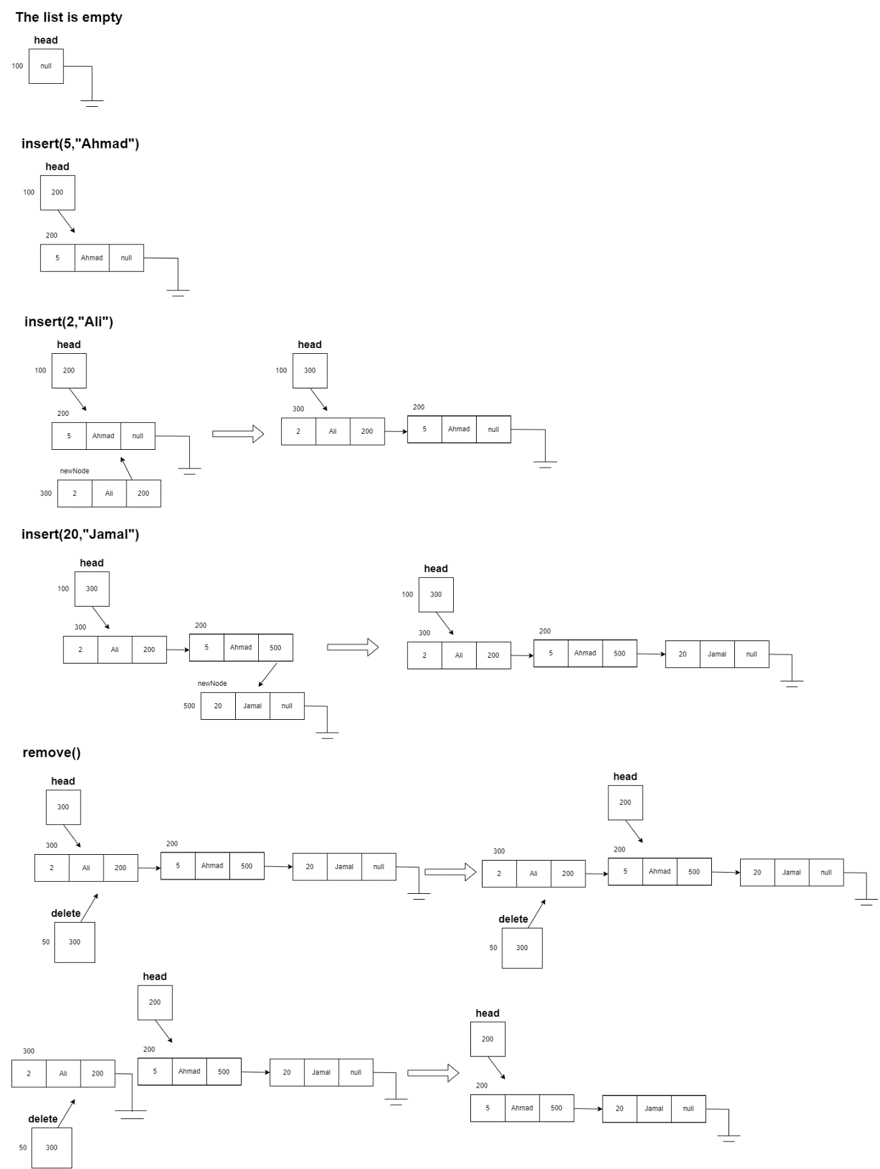
getMin() --> Ahmad

Selection Sort VS Merge Sort
Selection sort | 5000 | 50000 | 500000
Sorted | 15mS | 1935mS | 188711mS
Reversely sorted | 16mS | 1037mS | 98446mS

- Selection Sort

- Merge Sort
Merge sort | 5000 | 50000 | 500000
Sorted | 1mS | 8mS | 70mS
Reversely sorted | 1mS | 7mS | 74mS

- Best case and worst case
 | Selection Sort | Merge Sort
Best Case | O(n^2) | O(n log n)
Worst Case | O(n^2) | O(n log n)

Performance of Sorting Algorithm (Selection sort and merge sort)

Time Complexity
Time complexity is the relationship between run-time/execution-time and input size. It is a way to express that how run time is increasing, when the input size is increasing.
So, it is a way to express and describe the relationship between run time and input size in a word, just like constant or linear….
There is another way to describe the relationship between run time and input size, and it is more mathematical way, called Big O notation.

Big O notation
It is more mathematical way to describe and express the relationship between execution time and input size, by 2 steps after finding the equation
- find the fastest growing term
- take out the coefficient
By these 2 steps, we can find the Big O notation for any equation we have.

Selection Sort:
There is almost no difference in terms of the time taken to run the selection sort (the numbers in the selection sort table in each column), even if the data is sorted or reversely sorted.
Time complexity/Big-O: on sorted data, O(n^2) | on reversely sorted data, also O(n^2)
- Merge Sort:
Also, there is almost no difference in terms of the time taken to run the selection sort (the numbers in the merge sort table in each column), even if the data is sorted or reversely sorted.
Time complexity/Big-O: on sorted data, O(n log n) | on reversely sorted data, also O(n log n)
Big-O | Selection Sort | Merge Sort
Sorted | O(n^2) | O(n log n)
Reversely Sorted | O(n^2) | O(n log n)

Both of the sorting algorithms are sorting data correctly, but the performance of the merge sort in terms of time is better/faster than the selection sort. While the time complexity/Big-O of selection sort is O(n^2), the time complexity/Big-O of merge sort is O(n log n), that is simply why merge sort is better than selection sort in terms of time.
For example, if the input size is 5000 and the data is sorted or reversely sorted, for merge sort needs about 1mS, while the selection sort needs about 16mS, it is so clear that the merge sort performance is better and faster than the selection sort performance in terms of time. So, O(n log n) is better than O(n^2).
In selection sort, the time complexity is O(n^2) in all cases, that’s mean the relationship between the input size and the time grows quadratically on sorted data or even on reversely sorted data, because selection sort selects each item and compare it with the other items and swap items if needed. Selection sort always and only depends on the input size, so in all cases the time complexity/big-O will be O(n^2).
In merge sort, the time complexity is O(n log n) in all cases, that’s mean when the input size increase (n), the number of operations will increase proportionally for n multiplied by log n. that is because the merge sort algorithm follows the divide and conquer, so it is divide the array into two sub array, until it cannot divide anymore, and sort each sub array, then merge the solutions. Merge sort only depends on the input size too, so in all cases the time complexity/big-O will be O(n log n).
Merge sort's time complexity, make a low number of comparisons and swaps more than selection sort. Divide and conquer strategy, make the performance of merge sort more efficient than the performance of the selection sort in terms of time.

Explain the Result
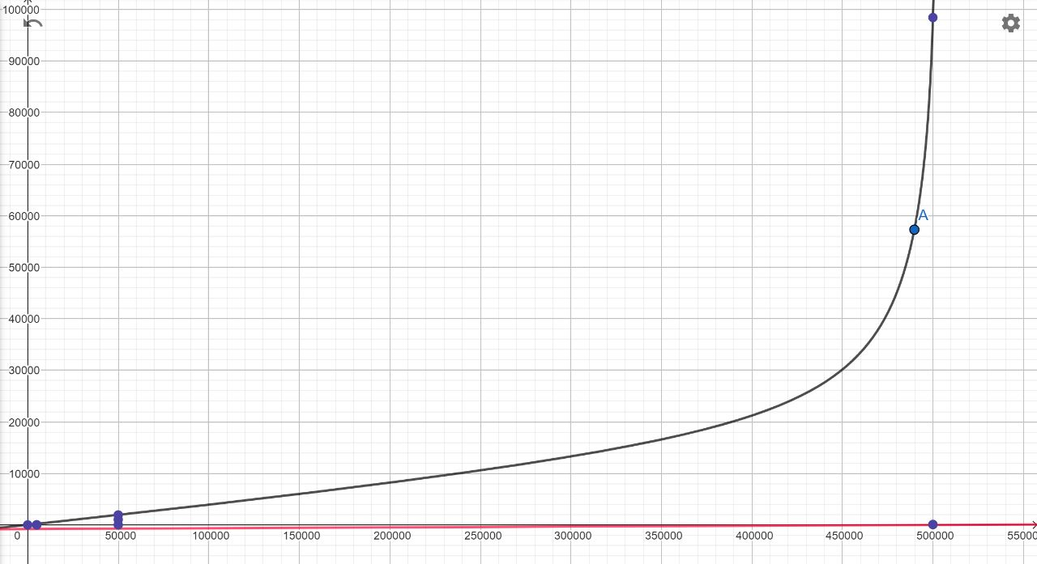
Selection Sort, time complexity (relation between input size and time by the result that is in the table)
Merge Sort, time complexity (relation between input size and time by the result that is in the table)

Space Complexity
There is another measure that can be used to compare the efficiency between algorithms which is not in terms of time, it is in terms of space. This measure called space complexity.
It is the relationship between the space/memory and the input size, how much extra space does the piece of code need when the input size gets larger.

Analyze the Operations of the Dijkstra’s Algorithm
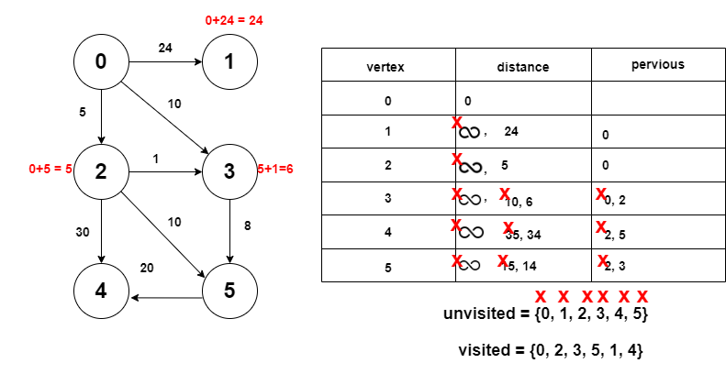

Analyze the Operations of the Bellman-Ford Algorithm
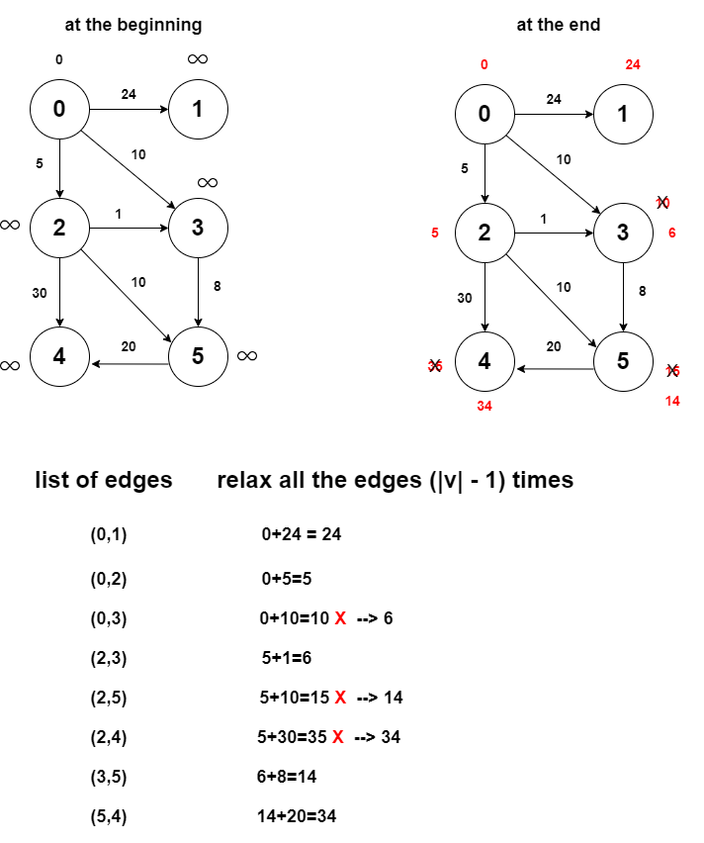

Stack Data Structure

Pseudocode of Palindrome
isPalindrome(str[], size) {
str convert to lowercase
mid size / 2
for i 0 to mid – 1 {
push(str[i])
}
if size odd {
i++
}
while(i < size) {
t top()
if t != str[i] {
return false
}
pop()
i++
}
return true
}

Abstract Data Type

Stack, Formal Definition:
It is a list (collection of items with the same type) and it is allowed insert and remove operations only on one side called, the top of the stack.

Stack Operations:
All operations should take, constant time/O(1)
The main two operations
- insertion, called push. Insert an element/item
- removing, called pop, remove an element/item

- top, get the data that is in the element at the top of the stack
- isEmpty, the stack is empty or not

Logical view

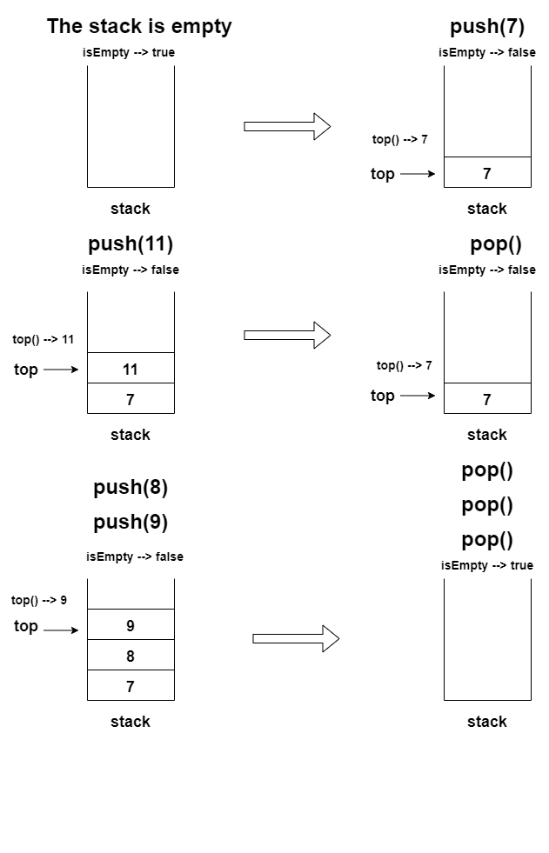

The Call Stack
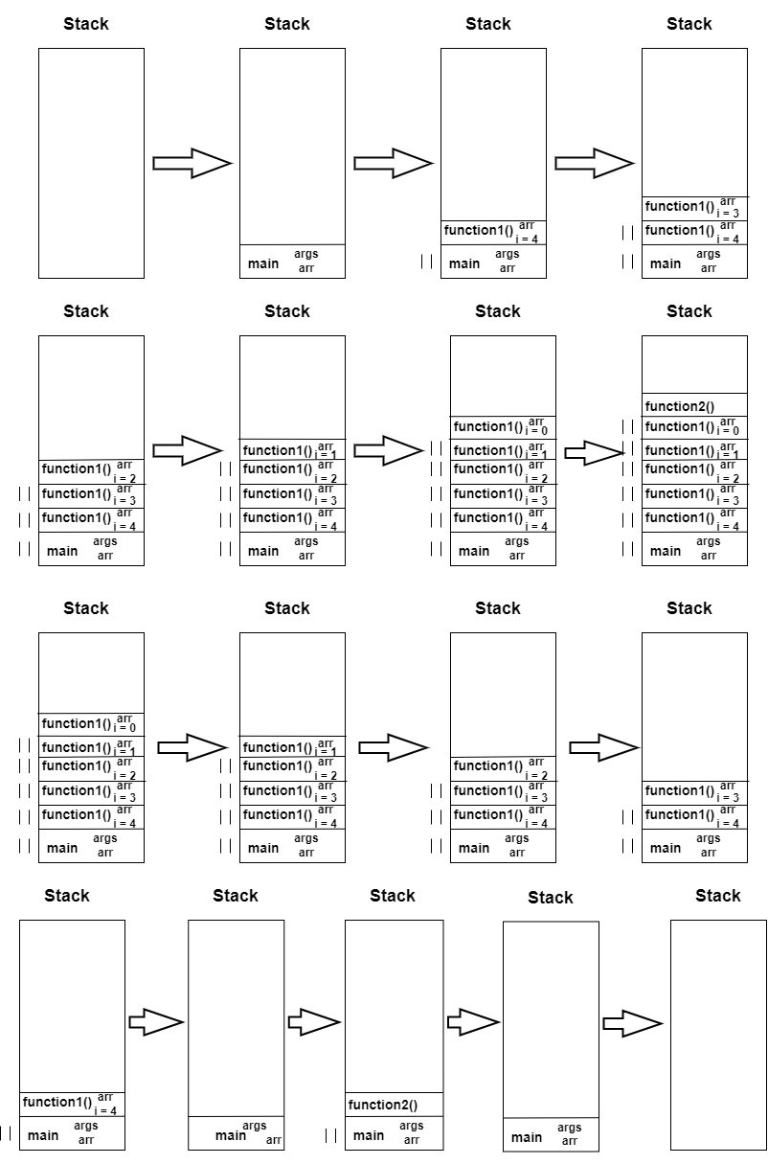

Spell Checker Application and Priority Queues
 | Linked List | Array unsorted | Array sorted
Search | O(n) | O(n) | O(log n)
Insert | O(n) | O(n) | O(n)
Remove | O(1) | O(n) | O(n)

Linked List
- linear search
- insert to anywhere in the list
- remove from one side
Array unsorted
- linear search
- insert to anywhere in the list
- remove from the anywhere in the list
Array sorted
- binary search
- insert to anywhere of the array
- remove from anywhere

Spell Checker Application
- Data Structure: Array Sorted
- Justification: the most requested and used operation of the spell checker application is the search operation. The words are sorted alphabetically in the dictionary, and this will lead to an efficient search by using binary search, to search for the required word. The binary search was used due to its time complexity, which is O(log n), so the binary search is more efficient than the linear search in terms of time, that the linear search with time complexity, O(n). binary search cannot be implemented in unsorted array and linked list.
Also, there is an insertion operation with O(n) (time complexity) to maintain the order of the words in the array, in addition to the remove operation, so can be removed any element in the array, in O(n) time complexity.

Priority Queues
- Data Structure: Linked List
- Justification: it can provide a dynamic list, the priority can be associated with the data regardless of its data type (of data), so it is easy to implement. The linked list provides an efficient insertion operation with O(n) time complexity, also provides an efficient remove operation (remove the item that is in the front) in O(1) time complexity, it is only the remove operation using linked list in the table with O(1) time complexity. So, linked list is the most efficient data structure to implement priority queues based on the table.

Evaluate and calculate Running Time/Big-O

Calculate the Running Time
- n, index / c, constant
- T(n) = T(n - 1) + T(n - 2) + T(n - 5) + c
- Calculate the upper bound for T(n)
- T(n) = T(n - 1) + T(n - 1) + T(n - 1) + c
- T(0) = 1
- T(n) = 3T(n - 1) + c
- Substitute T(n) in the equation
- T(n) = 3 (3T(n - 1 - 1) + c) +c
- T(n) = 9T(n - 2) + c
- Substitute T(n) (from the original equation) in the last equation
- T(n) = 9(3T(n – 2 -1) + c) +c
- T(n) = 27T(n - 3) + c
- Substitute
- T(n) = 27 (3 T(n – 3 - 1) + c) + c
- T(n) = 81T(n - 4) + c
- After k steps
- T(n) = 3^k T(n - k) + c
- At the final step:
  - T(0) = T(n - k)
  - 0 = n – k
  - n = k
- T(n) = 3^nT(0) + c , T(0) = 1
- T(n) = 3^n + c
- Fastest growing term, and remove other terms and remove the coefficient
- T(n) = 3^n
- O(3^n)

Evaluation
It a recursive function, the usage of recursion provides an easier implementation, but from other side, this function has O(3^n) time complexity, which is one of the worst types of time complexity (exponential time complexity), so the running time grows and increases exponentially when the input size increases, which indicates that this function is not efficient in terms of time.

Advantages of Encapsulation When Implementing any Data Structure as Abstract Data Type
Encapsulation is a wrapping the data and operations (put it in a capsule).

Data hiding / Abstraction
Hide the implementation details of the data structure from the outside access, users will not know any background about the implementation details in the class. for example, it is not visible to the user how to create nodes. Also, there is some operations in the code just for the reusability and it should not be visible to the user. Users will not know how the data is stored or how it will be managed. It provides a boundary between the implementation details and the user interface, users can deal with the data structure by abstracted interface. Its importance lies in the fact that it reduces complexity and hides unnecessary data or operations (implementation details)

Data Protection
Encapsulation helps to protect the data that is stored in the data structure, through wrapping the data and control access using setters and getters methods. This point related to the security, by control access. Certainly, data protection is indispensable, as it is extremely important.

Flexibility
Encapsulation provides the flexibility to modify the implementation details of the data structure without to affecting on the code that is used. This point provides a maintenance and enhancement, in the future. The maintenance is very important and necessary to update and enhance.

Easy to Test
The encapsulated code is easy to test.

Freedom to the Programmer in the Implementation Details
Encapsulation provides the freedom to the programmer to implement the details of the system, the programmer just has to maintain the abstract interface that users deal with.
Encapsulation in Java - GeeksforGeeks

ADTs are a Basis for Object Oriented Programming
I agree with the view imperative ADTs are a basis for object-oriented programming, so there is a general connection between them, ADTs align to set a bounder between the abstract interface and the implementation details, so the OOP follows these concepts through the abstraction and encapsulation concepts, this indicates that the ADTs is the basis of OOP. while the imperative ADTs don’t include the all concepts of the object-oriented programming. ADTs are the core of OOP abstraction and encapsulation, so ADTs are the base of OOP (abstraction and encapsulation), and the rest of OOP concepts (inheritance and polymorphism) stem from it to supplement it.

Implementation Independent Data Structures
- Focus on the logical aspects of the data structure
It is so important to understand and focus on the idea of this data structure and its operations, by understand what the functionality of each operation. It is important when deal with the abstract interface/user interface.
- Flexibility
We can implement it in different programming languages, as long as operations a behaviour maintained. And this is true we can implement any data structure in different languages (that contains OOP) like java, python, C++, …
This provides more flexibility to choose the programming language that you want (provided that it contains OOP), the flexibility is very important factor.
- Efficient memory use
Through the efficient use of the data structure, memory can be optimized, by the logic, when the input size is known (static), almost the implementation will be using arrays. If the input size is uncertain, almost the implementation will be using linked list (dynamic). This will actually optimize memory usage.
- Reusability
Code reuse is allowed, if any data structure is implemented, it can be reuse (reuse it without know the implementation details). Data structures implementations can be found in packages and libraries, so that can be used, using libraries (without know how are implemented) by just to know the idea of operations, it so easy to apply the reusability, it is very important too. Reusability also enables the developers to exchange the different implementations that are related to the same abstract data type, as long as they take on to the specific interface.

